HOSPITAL MANAGEMENT

1. HOSPITAL MANAGEMENT- APPOINTMENT

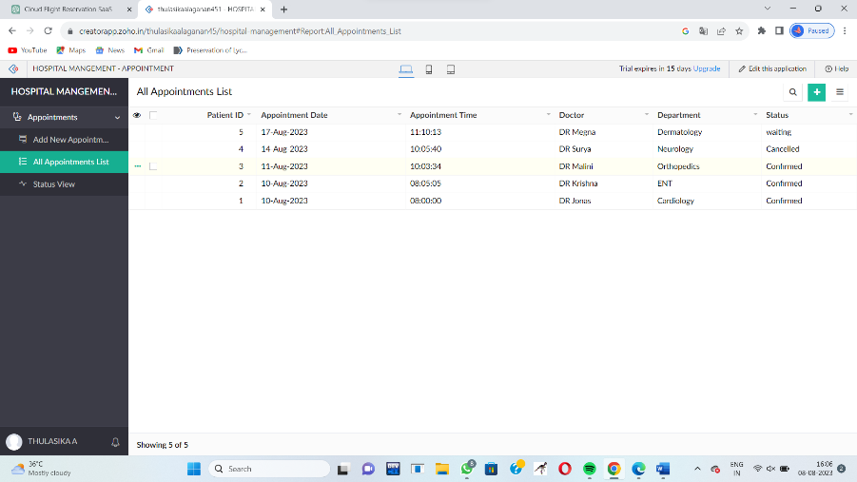

2. HOSPITAL MANAGEMENT- PATIENT DETAILS

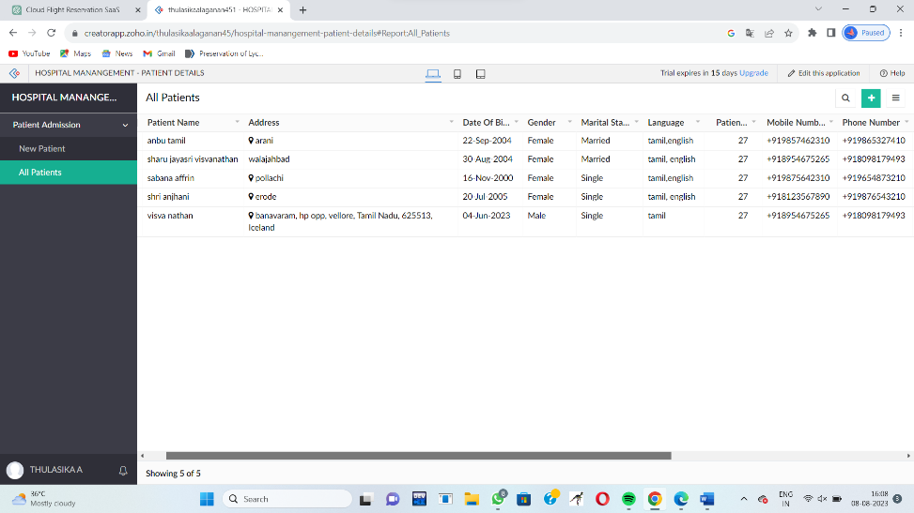

3.HOSPITAL MANAGEMENT – labs and tests

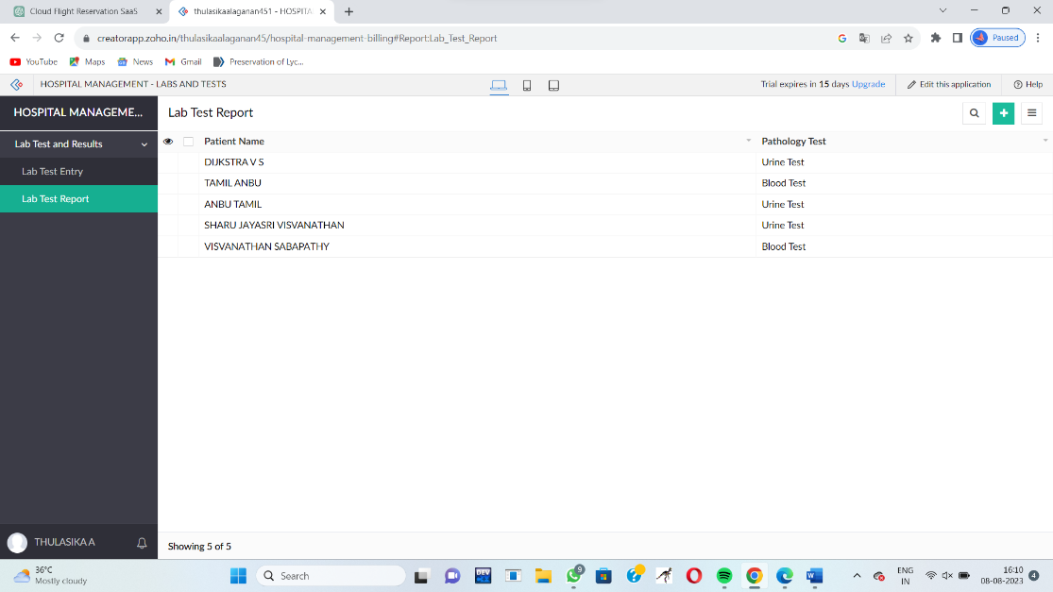

4. HOSPITAL MANAGEMENT - consultation

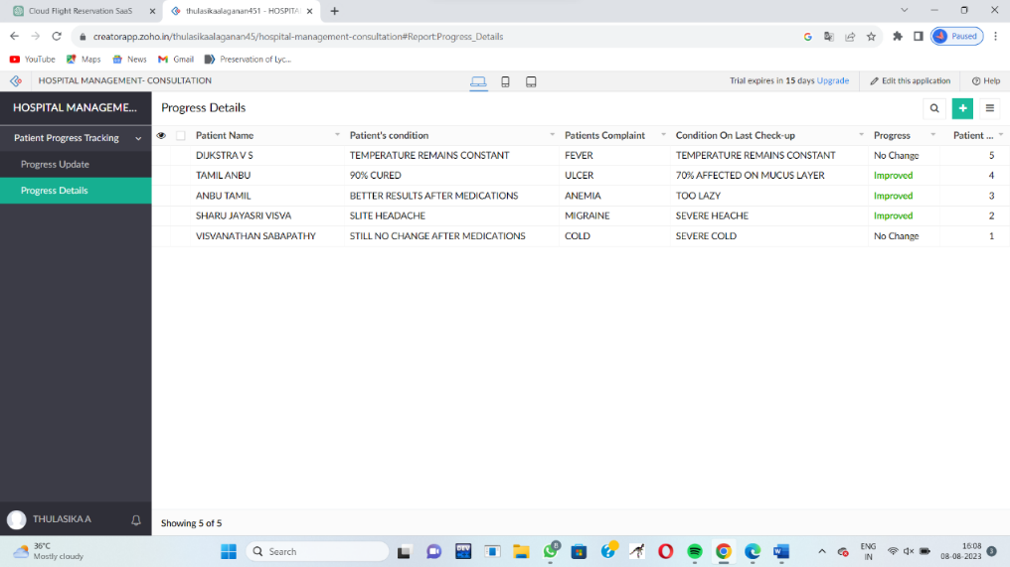

5. HOSPITAL MANAGEMENT- STAFF DETAILS

